Step 1: python –version
Step 2: create venv - python -m venv yolov8 , To activete >> yolov8\Scripts\activate
Step3: install yolo - pip install Ultralytics
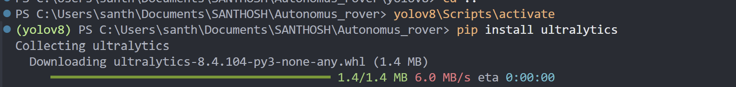
Step 4: start training yolo detect train data=dataset/data.yaml model=yolov8n.pt epochs=100 imgsz=640 batch=16
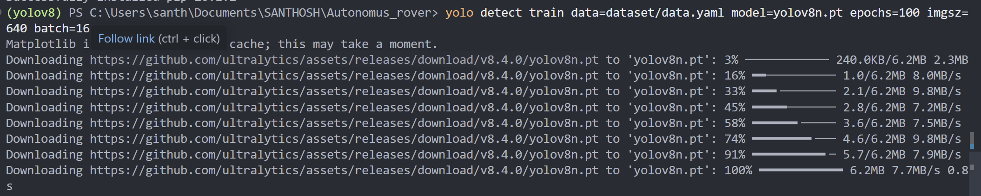
Step 5: check output - yolo detect predict model=best.pt source=test.jpg
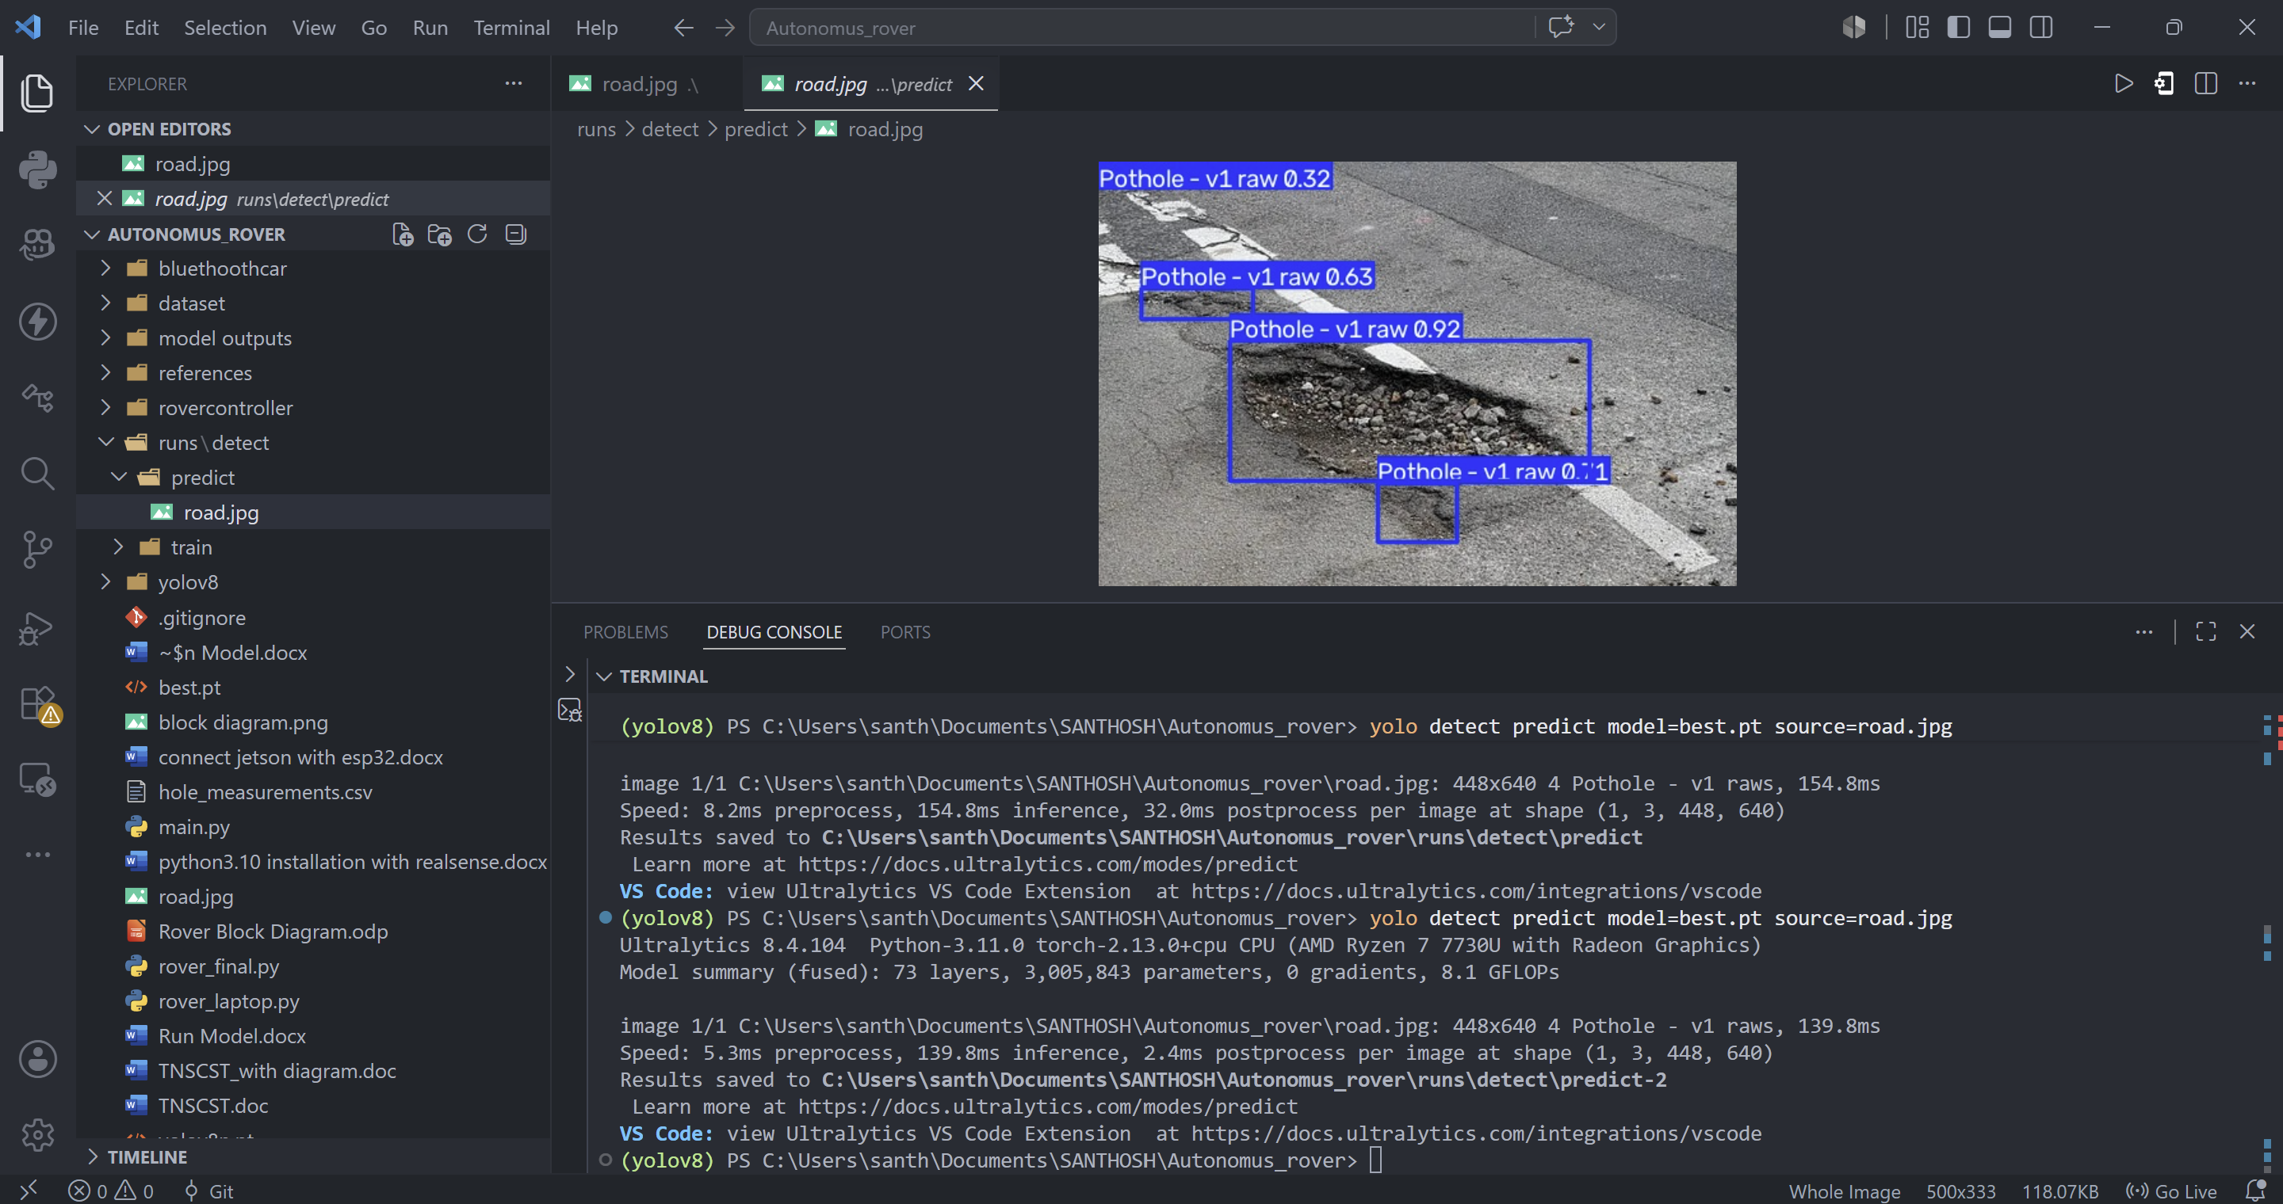
Step 6: deactivate .venv
(yolov8) PS C:\Users\santh\Documents\SANTHOSH\Autonomus_rover> deactivate
PS C:\Users\santh\Documents\SANTHOSH\Autonomus_rover>

Understanding

Workflow 1: Label in Roboflow → Train Locally (Recommended)
This is the workflow most developers use.
Collect Images
│
▼
Upload Images to Roboflow
│
▼
Label Objects
│
▼
Generate Dataset Version
│
▼
Download Dataset (YOLOv8 format)
│
▼
Train using Ultralytics YOLO locally
│
▼
best.pt
│
▼
Test
│
▼
Deploy on Robot
In this workflow:
- Roboflow is only used for:
  - Image upload
  - Annotation (labeling)
  - Dataset preprocessing (resize, augmentation if chosen)
  - Exporting the dataset
The actual AI model is trained on your own computer using:
yolo detect train ...
The result is:
best.pt
This is the workflow I recommend if you have a decent GPU.

Workflow 2: Label in Roboflow → Train on Roboflow
This is what you have done already.
Images
│
▼
Roboflow
│
▼
Label Images
│
▼
Train inside Roboflow Cloud
│
▼
Roboflow Model
Roboflow trained this model:
YOLOv11 Nano
and produced metrics such as:
mAP = 68.4%
Precision = 84.8%
Recall = 55.6%
These numbers describe the performance of the model trained on Roboflow's cloud, not on your local machine.

What happens when you download the dataset?
When you click Download Dataset → YOLOv8, Roboflow gives you:
train/
valid/
test/
data.yaml
It does not download the trained model.
It downloads only the labeled dataset.
Then you train it yourself.
For example:
yolo detect train data=data.yaml model=yolov8n.pt epochs=150 imgsz=640
Now Ultralytics trains a new model from the dataset.
At the end you obtain
best.pt
This best.pt is not the same file as Roboflow's cloud-trained model—it is your own locally trained model.

Why choose "YOLOv8" when downloading?
This confuses many beginners.
When you select
Download Dataset
↓
YOLOv8
you are not downloading a YOLOv8 model.
You are downloading the dataset in a folder structure and annotation format that Ultralytics YOLO (v8, v9, v10, v11) understands.
For example:
train/images
train/labels

valid/images
valid/labels

test/images
test/labels

data.yaml
This is just the dataset format.

What does this command do?
yolo detect train \
model=yolov8n.pt \
data=data.yaml \
epochs=150
It means:
Start with the pretrained YOLOv8 Nano weights (trained on COCO)
│
▼
Fine-tune those weights using my dataset
│
▼
Save the best-performing weights as best.pt

Why start from yolov8n.pt?
Ultralytics provides pretrained weights such as:
yolov8n.pt
yolov8s.pt
yolov8m.pt
yolov8l.pt
yolov8x.pt
These models already know general features like edges, shapes, textures, people, cars, etc., because they were trained on the COCO dataset.
When you train on your own dataset, the model adapts that knowledge to your specific classes. This process is called transfer learning and usually gives much better results than training from scratch.

What happens during epochs?
Suppose you have
1000 images
epochs = 150
The model will see
1000 images
× 150 passes
-------------
150,000 image presentations
During each epoch:
Read image
│
▼
Predict boxes
│
▼
Compare with ground truth labels
│
▼
Compute error (loss)
│
▼
Update model weights
Over many epochs, the loss generally decreases and the predictions improve.

Your complete understanding
Capture Images
│
▼
Upload Images to Roboflow
│
▼
Label Images
│
▼
Generate Dataset Version
│
▼
(Optional) Train on Roboflow Cloud to evaluate the dataset
│
▼
Download Dataset (YOLO format)
│
▼
Train locally with Ultralytics
│
▼
best.pt
│
▼
Test the model
│
▼
Deploy on your Autonomous Rover

yolo detect train data=dataset/data.yaml model=yolov8n.pt epochs=100 imgsz=640 batch=16
This command tells Ultralytics YOLO to train an object detection model.
Part | Meaning
yolo | Run the Ultralytics YOLO program.
detect | Perform an object detection task (find and classify objects with bounding boxes).
train | Train the model on your dataset.
data=dataset/data.yaml | Use the dataset described in data.yaml. This file contains the paths to your training, validation, and test images, along with the class names.
model=yolov8n.pt | Start from the pretrained YOLOv8 Nano weights. This is the base model that will be fine-tuned on your dataset.
epochs=100 | Train for 100 complete passes through the training dataset.
imgsz=640 | Resize every image to 640 × 640 pixels before feeding it into the model.
batch=16 | Process 16 images at a time before updating the model weights.

What exactly is an epoch?
An epoch means the model has seen every training image once.

Example
Suppose you have:
- 1,000 training images
- batch=20
- epochs=100
During one epoch:
1000 images
÷ 20 images per batch
----------------------
50 batches
The model processes:
Batch 1 -> 20 images
Batch 2 -> 20 images
...
Batch 50 -> 20 images
After all 50 batches are completed, one epoch is finished.
Then it starts again from the first image for the next epoch.

What happens during each epoch?
For every batch of images, the model:
Input image
│
▼
Predict bounding boxes
│
▼
Compare predictions with the true labels
│
▼
Calculate the error (loss)
│
▼
Adjust the model's weights
This process repeats until all images have been used once.

Why train for multiple epochs?
The model usually isn't accurate after seeing the dataset only once.
For example:
Epoch 1
Accuracy: 20%

Epoch 20
Accuracy: 65%

Epoch 50
Accuracy: 82%

Epoch 100
Accuracy: 91%
Each epoch helps the model learn better features and improve its predictions.

Can too many epochs be a problem?
Yes.
If you train for too many epochs, the model may start memorizing the training images instead of learning patterns that generalize to new images. This is called overfitting.
YOLO helps prevent this with features like early stopping (controlled by the patience parameter), which can stop training if the validation performance stops improving.

Visualizing 100 epochs
If your dataset contains 500 images and you train with:
epochs=100
then the model will see:
500 images × 100 epochs = 50,000 image presentations
It's the same 500 images, but the model improves a little each time by adjusting its internal weights.

In simple terms
Think of it like preparing for an exam:
- Dataset = Your textbook
- 1 epoch = Reading the entire textbook once
- 100 epochs = Reading the textbook 100 times, understanding it better with each pass
- best.pt = The version of your knowledge when your test performance was the best
So in your command:
yolo detect train data=dataset/data.yaml model=yolov8n.pt epochs=100 imgsz=640 batch=16

best.pt does not contain your images or labels.
It contains the learned neural network weights—the parameters the model has adjusted during training so it can recognize objects.

Think of it like this
Imagine you're teaching a child to recognize traffic cones.
You show them 1,000 pictures.
After learning, you throw away the pictures.
The child still knows what a traffic cone looks like.
The child's knowledge is equivalent to best.pt.

What is inside best.pt?
It is a PyTorch model checkpoint that typically contains:
- ✅ Model architecture information
- ✅ Learned weights (millions of numbers)
- ✅ Bias values
- ✅ Training metadata (depending on the save format)
- ✅ Class information and configuration needed for inference
It does not contain:
- ❌ Your dataset images
- ❌ Label .txt files
- ❌ The entire dataset

What are "weights"?
A neural network is made up of many layers.
A very simplified view:
Image
│
▼
Layer 1
│
▼
Layer 2
│
▼
Layer 3
│
▼
Prediction
Each connection has a number called a weight.
Example (simplified):
0.2384
-1.5932
2.4387
0.0041
-0.8322
...
YOLOv8 Nano has millions of these values.
Training adjusts them to make better predictions.

During training
Initially:
Image
↓
Prediction:
Dog ❌
The model makes mistakes.
After computing the error, it changes the weights:
Weight 1:
0.42 → 0.39

Weight 2:
-1.20 → -1.08

Weight 3:
2.80 → 2.76
This happens over and over during training.
Eventually:
Image
↓
Prediction:
Rock ✔
Confidence: 98%
The collection of all those learned weights is what gets saved in best.pt.

Why is it called best.pt?
Suppose you train for 100 epochs.
The validation accuracy might look like:
Epoch | mAP
1 | 30%
10 | 65%
25 | 82%
40 | 91% ✅
60 | 90%
80 | 88%
100 | 87%
The best performance occurred at epoch 40.
YOLO automatically saves that checkpoint as:
best.pt
The weights from the final epoch (100) are saved separately as:
last.pt
So best.pt is usually the model you want to use for inference because it achieved the best validation performance.

Is best.pt an image?
No.
It's a binary file containing millions of learned parameters.
For example:
best.pt
├── Model structure
├── Layer weights
├── Bias values
├── Training metadata
└── Configuration

How is it used?
When you run:
yolo detect predict model=best.pt source=image.jpg
YOLO:
- Loads the learned weights from best.pt.
- Loads your input image.
- Passes the image through the network.
- Uses the learned weights to detect and classify objects.
- Returns the predicted bounding boxes and confidence scores.

In your Autonomous Rover project
Your workflow is:
Camera
│
▼
Capture Image
│
▼
best.pt
│
▼
YOLO Model
│
▼
Detect:
• Rock
• Person
• Tree
• Obstacle
│
▼
Return:
Class + Bounding Box + Confidence
│
▼
Rover decides how to move

